A000-Asia-Nepal-Kathmandu-Yaksi with Bird-Newari Statue-Wood-18th c

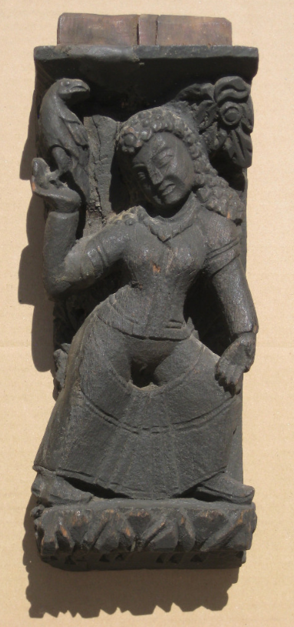 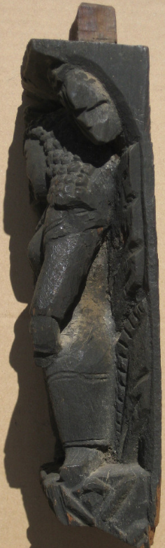 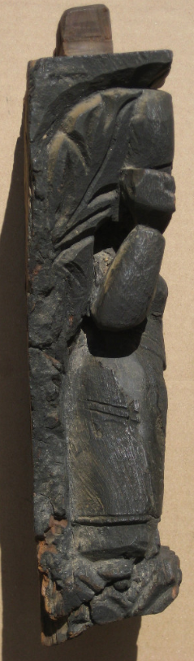 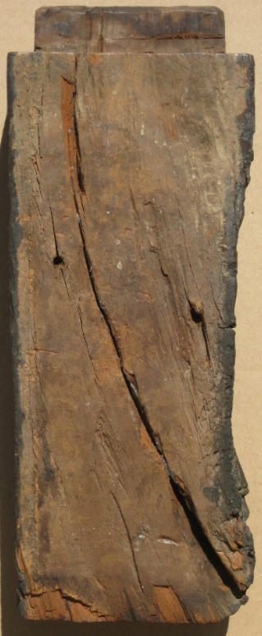

A000-Asia-Nepal-Kathmandu-Yaksi with Bird-Newari Statue-Wood-18th c

Case No.: 3

**Accession No.**

**Formal Label:** Asia-Nepal-Kathmandu-Yaksi with Bird-Newari Statue-Wood-18th c

**Display Description:**

This is a traditional Yaksi holding a bird in her right hand illustrative of beckoning fertility. Probably from a window in a Newari home in Kathmandu valley. She is naked in her genital area, presumably an allusion to fertility.

**LC Classification:**

**Date or Time Horizon: 18th c**

**Geographical Area:** Kathmandu Valley

**Map:**

**GPS coordinates:**

**Cultural Affiliation:**

**Medium: iron wood**

**Dimensions:**

**Weight:**

**Condition: original**

**Provenance:**

**Discussion:**

**References:**

# wood statue from Nepal, Kathmandu, Newari woman holding bird, fertility

Late 18th century statue from a window in Kathmandu.  Very heavy wood.  Two old, very minor repairs. Otherwise, in fine condition. 12 inches high.